AI Assisted Coding

Lab Test – 04 Date: 12.11.2025 24BTCAICSB01 and 24BTCAICSB02

=================================================================================
SET 2
Q1. With AI assistance, create a Vehicle Service Management database.
- Include tables: Customers, Vehicles, Service_Records.
- Insert Data in to these three tables
- Write a query to find all vehicles serviced in the last 30 days.
Q2. Use AI to translate a JAVA array sorting program into Python, and verify that both outputs match for a given array.

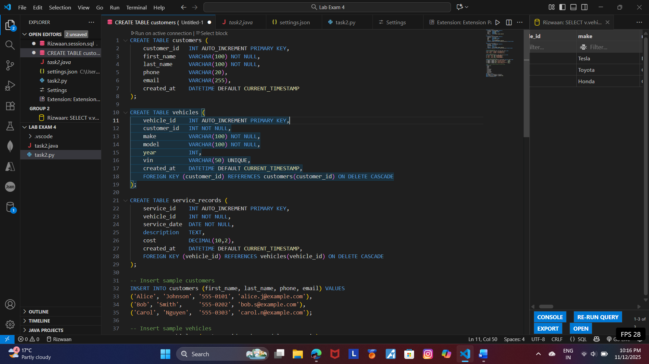
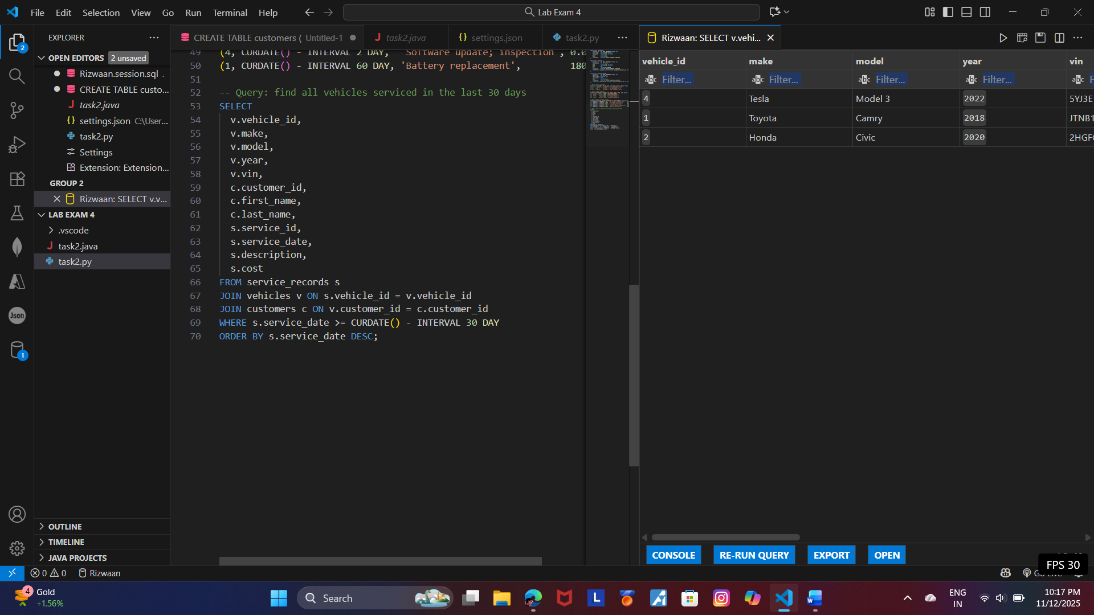

Task 2
